Posted 09/16/2015 at 2:06 pm by JAV

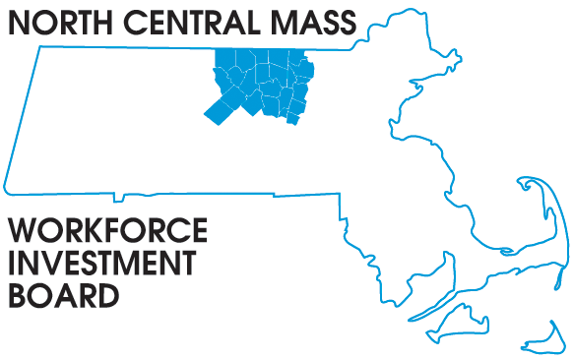
1355 Central Street Leominster, MA 01453 Phone: (978) 534 1023 Fax: (978) 534 1807

BOARD OF DIRECTORS MEETING

Tuesday, September 22, 2015

North Central Chamber of Commerce
860 South Street Fitchburg, MA
8:00 a.m. – 9:30 a.m.

AGENDA

Welcome & Introductions

Welcome new members Paulette Carroll our Career Center Director, replacing Mark Wigler who recently retired, Christine Cordio Director of ABE programs from Clinton, Linda Comforti, from Leominster Hospital, Jeff Crowley, President of Wachusett Mountain, Pierre Grouleau and Christopher Mattioli our new Labor representatives.

Approve Minutes of the June 9, 2015 meeting (Vote required)

Executive Committee report Martha Chiarchiaro (Vote required)
Finance report Barbara Mahoney

Presentations

What is disability and Why does it matter
Kathy Petkauskos Work Without Limits

Agency Overview and Employer Engagement Initiatives
Jeff Roberge Massachusetts Rehabilitation Commission

Grant Updates
DEI-V Theresa Kane

Directors Report: NEG Sector grant, WIOA implementation, WCTF RFP & Workforce in the NEWS

Other Business

